**Browser**

| **Browser** | **Privacy and Security** | **Speed and Performance** | **Key Features** |
| --- | --- | --- | --- |
| **Google Chrome** | Good security but collects user data | Very fast, optimized for modern web | Large extension ecosystem, Google sync |
| **Mozilla Firefox** | High privacy with built-in tracker blocking | Fast and efficient, especially on CPU | Open source, privacy-focused, highly customizable |
| **Microsoft Edge** | Strong security features, Chromium-based | Very fast, good resource management | Windows integration, reading mode, collections |
| **Safari** | Strong privacy with intelligent tracker blocking | Optimized for Apple devices | Apple ecosystem integration, low battery consumption |
| **Brave** | Privacy-focused, blocks ads and trackers by default | Fast, Chromium-based | Private browsing by default, crypto rewards |

**Differences between a website and blog**

| **Characteristic** | **Website** | **Blog** |
| --- | --- | --- |
| **Structure** | Static content, organized by sections like "Home," "Services," "Contact." | Dynamic content, organized chronologically with recent posts. |
| **Updates** | Less frequent updates, usually with significant changes. | Regular posts, often following an editorial calendar. |
| **Interaction** | Limited; may include contact forms or social media links. | High; allows comments, social sharing, and subscriptions. |
| **Purpose** | To present institutional or commercial information in a formal way. | To share opinions, experiences, news, or knowledge in a personal manner. |
| **Design** | More formal and professional, aligned with corporate identity. | More flexible and customizable, with emphasis on content readability. |
| **SEO (Search Ranking)** | May be more challenging due to static content. | Benefits SEO due to fresh and regularly updated content. |
| **Monetization** | Through services, products, or direct sales. | Via advertising, affiliate marketing, sponsored content, or subscriptions. |

**TYPES OF NETWORKS**

1. **Personal Area Network (PAN)**

* **Range:** Very limited, typically within a few meters.
* **Common use:** Connecting personal devices such as phones, tablets, computers, and peripherals (e.g., Bluetooth connection between a phone and headphones).
* **Associated technologies:** Bluetooth, infrared, USB.

1. **Local Area Network (LAN)**

* **Range:** Limited to a small geographic area, such as an office, school, or home.
* **Common use:** Connecting computers and devices within a building or a group of nearby buildings.
* **Associated technologies:** Ethernet, Wi-Fi.
* **Example:** Home or office network.

1. **Campus Area Network (CAN)**

* **Range:** Covers a larger geographic area than a LAN, such as a university campus or business complex.
* **Common use:** Connecting multiple LANs within a campus to facilitate communication and resource sharing.
* **Associated technologies:** Gigabit Ethernet, fiber optics.
* **Example:** University network connecting several buildings.

1. **Metropolitan Area Network (MAN)**

* **Range:** Covers a larger geographic area than a LAN, typically a city or metropolitan area.
* **Common use:** Connecting multiple LANs within a geographic region to facilitate communication on a larger scale.
* **Associated technologies:** Fiber optics, WiMAX, DSL.
* **Example:** City communication network connecting various buildings and public services.

1. **Wide Area Network (WAN)**

* **Range:** Covers a large geographic area such as a country or continent.
* **Common use:** Connecting multiple LANs and MANs at a national or international level.
* **Associated technologies:** MPLS, Frame Relay, X.25, Internet.
* **Example:** Internet, corporate network connecting offices in different countries.

1. **Storage Area Network (SAN)**

* **Range:** Generally within a data center or enterprise facility.
* **Common use:** Providing high-performance data storage access to servers and devices.
* **Associated technologies:** Fibre Channel, iSCSI.
* **Example:** Enterprise storage infrastructure for databases and critical applications.

1. **Global Area Network (GAN)**

* **Range:** Covers very large geographic areas such as multiple continents.
* **Common use:** Connecting mobile and satellite networks globally.
* **Associated technologies:** Mobile networks, satellites.
* **Example:** Mobile telecommunications networks operating in several countries.

1. **Virtual Private Network (VPN)**

* **Range:** Uses a public network (like the Internet) to create a secure connection between devices.
* **Common use:** Allowing users to securely access a private network from remote locations.
* **Associated technologies:** Encryption, protocols like IPsec, SSL/TLS.
* **Example:** Remote access to a corporate network from home or while traveling.

**NETWORK TOPOLOGIES**

**Bus Topology**

* **Description:** All devices are connected to a single central cable (bus).
* **Advantages:** Easy to implement and cost-effective.
* **Disadvantages:** If the bus fails, the entire network is affected.
* **Usage:** Suitable for small or temporary networks.

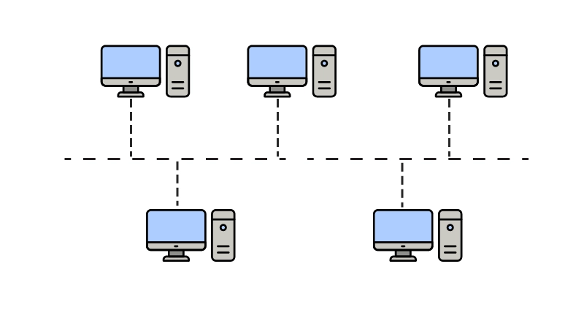

**Ring Topology**

* **Description:** Each device is connected to exactly two other devices, forming a circular data path.
* **Advantages:** Data flows in one direction, reducing collisions; easy to install and manage.
* **Disadvantages:** If one device or connection fails, it can affect the entire network; troubleshooting can be difficult.
* **Usage:** Suitable for small to medium-sized networks where predictable performance is needed.

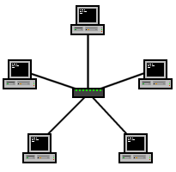

**Star Topology**

* **Description:** Each device is connected to a central point (hub or switch).
* **Advantages:** Easy to manage and expand.
* **Disadvantages:** Dependency on the central point; if it fails, the entire network is affected.
* **Usage:** Common in home and office networks.

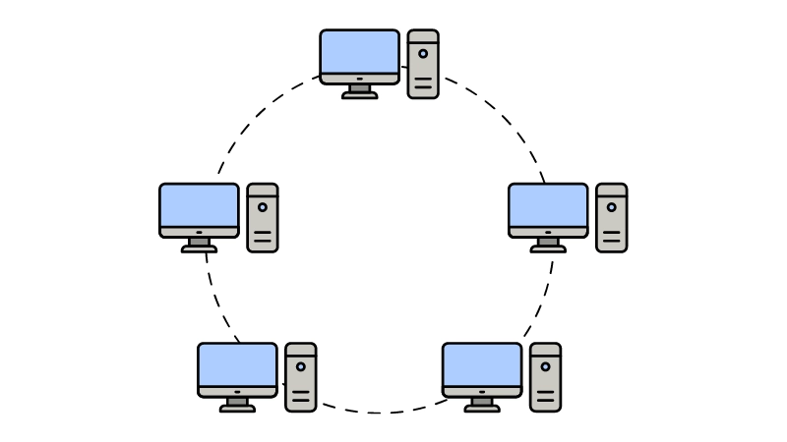

**Tree Topology**

* **Description:** Combination of star and bus topologies; it has a hierarchical structure.
* **Advantages:** Scalable and flexible.
* **Disadvantages:** Complex to configure and maintain.
* **Usage:** Suitable for large and complex networks.

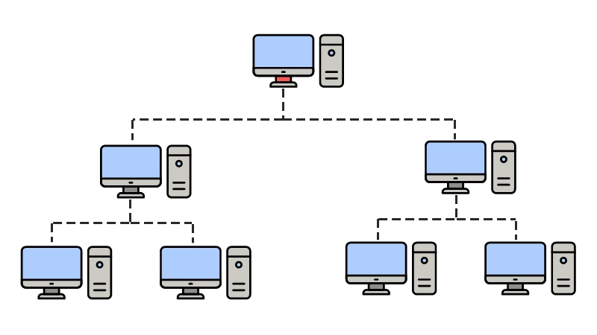

**Mesh Topology**

* **Description:** Every device is connected to all other devices.
* **Advantages:** High redundancy and reliability.
* **Disadvantages:** Expensive and complex to implement.
* **Usage:** Critical in networks where availability is essential.

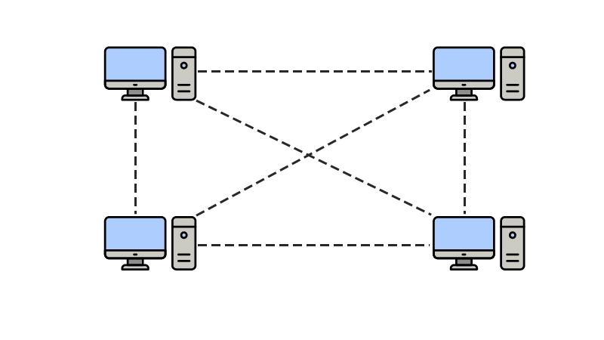

**Network Technologies**

Network technologies refer to the protocols and methods used to transmit data over a network. Some of the most common are:

1. **Ethernet**

* **Description:** Local Area Network (LAN) technology based on cables.
* **Characteristics:** High speed, reliability, and relatively low cost.

1. **Wi-Fi**

* **Description:** Wireless network technology to connect devices to a local network.
* **Characteristics:** Easy installation and mobility.

1. **Bluetooth**

* **Description:** Short-range technology to connect personal devices.
* **Characteristics:** Low power consumption and suitable for mobile devices.

1. **Fiber Optics**

* **Description:** Data transmission technology using light pulses through glass or plastic cables.
* **Characteristics:** High speed and capacity to transmit over long distances.

1. **Software-Defined Networking (SDN)**

* **Description:** Network architecture that allows centralized programming of traffic control.
* **Characteristics:** Flexibility, scalability, and simplified management.

**Types of Computer Networks**

Computer networks are classified according to their geographic range and purpose. Some of the main ones are:

1. **Personal Area Network (PAN)**

* **Range:** Up to 10 meters.
* **Use:** Connecting personal devices such as phones, tablets, and computers.
* **Example:** Bluetooth connection between a phone and headphones.

1. **Local Area Network (LAN)**

* **Range:** Up to several kilometers.
* **Use:** Connecting devices within a building or campus.
* **Example:** Home or office network.

1. **Campus Area Network (CAN)**

* **Range:** Covers a larger geographic area than a LAN, such as a university campus.
* **Use:** Connecting multiple LANs within a campus.
* **Example:** University network connecting several buildings.

1. **Metropolitan Area Network (MAN)**

* **Range:** Covers a city or metropolitan area.
* **Use:** Connecting several LANs within a geographic region.
* **Example:** City communication network.

1. **Wide Area Network (WAN)**

* **Range:** Covers an extensive geographic area, such as a country or continent.
* **Use:** Connecting multiple LANs and MANs at a national or international level.
* **Example:** Internet.